Coldwater Heritage Partnership

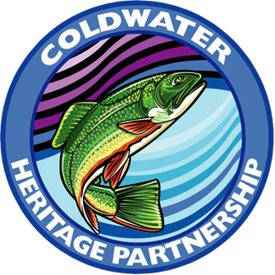

2022 Coldwater Conservation Planning & Implementation Grant Application – Round 27

All proposals must be received via email by Friday, March 4, 2022 at 4:00 PM.

Questions regarding this application can be directed to:

Coldwater Heritage Partnership
Rachel Kester, Program Director
595 E. Rolling Ridge Drive
Bellefonte, PA 16823
(814) 359-5233
Email: c-rkester@pa.gov

www.coldwaterheritage.org

Coldwater Heritage Partnership

The Coldwater Heritage Partnership is a collaborative effort between the Pennsylvania Fish and Boat Commission (PFBC), Pennsylvania Department of Conservation and Natural Resources (DCNR)*, Pennsylvania Council of Trout Unlimited (PATU), and the Foundation for Pennsylvania Watersheds (FPW).

The purpose of the Coldwater Heritage Partnership (CHP) is to provide leadership, coordination, technical assistance, and funding support for the evaluation, conservation, and protection of Pennsylvania's coldwater streams. For more information on the CHP program please visit www.coldwaterheritage.org.

*DCNR funding is made possible through the Community Conservation Partnership Program.

Coldwater Conservation Planning & Implementation Grants

- Purpose

Grants will be awarded to develop a Coldwater Conservation Plan or implement projects recommended in an existing Coldwater Conservation Plan (or similar document) to protect Pennsylvania’s coldwater streams. Grants of up to $7,500 will be awarded toward planning projects, while up to $10,000 will be awarded toward implementation projects.

- Eligible Applicants

Eligible applicants include the following: 501(c)3 non-profit organizations, conservation districts, counties, and municipalities. Organizations which do not have non-profit status in Pennsylvania must identify a 501(c)3 non-profit organization that will administer the finances for the grant (a pass-through organization). Grantees or their pass-through agent must provide proof of 501(c)3 status AND be registered with the Pennsylvania Bureau of Charitable Organizations.

- Program Funding Priorities

Proposals that meet the following criteria will be given priority:
- Project will occur in a watershed that contains streams with naturally reproducing trout populations. Priority will be given to streams that contain native brook trout, followed by those that contain wild trout of other species. Stocked trout streams are of low priority unless it is shown that improvements to the stream will directly benefit native and/or wild trout. Visit the PA Fish & Boat Commission’s website to find current trout stream designations: https://www.fishandboat.com/Fish/PennsylvaniaFishes/Trout/Pages/TroutWaterClassifications.aspx.
- Project will occur in a watershed listed as special protection waters within the Commonwealth of Pennsylvania’s Chapter 93 or have the potential to be upgraded. This information can be found at: http://www.pacodeandbulletin.gov/Display/pacode?file=/secure/pacode/data/025/chapter93/chap93toc.html&d=.
- Streams and other water bodies in the project area are located on public lands or are generally open to the public for recreational activities including angling.
- Project demonstrates significant partnerships, volunteer involvement, and promotes opportunities for citizen science and engagement.
- Local watershed organizations, TU chapters, county conservation districts, or academic institutions take the leading role in project implementation.
- Proposed project demonstrates benefits to coldwater fish species as well as to the local community’s economic, recreational, and aesthetic characteristics or objectives.
- Eligible Use of Funds & Required Match

CHP grants may be used to pay for labor costs, equipment, materials, meetings, engineering, construction activities and other services. Please review the CHP Mini Grant Policy found at: https://coldwaterheritage.org/index.php/grant-application-documents/ to ensure your proposal meets eligible use criteria set forth by DCNR. The maximum amount of funding per grant request is $7,500 for planning projects and $10,000 for implementation projects.

Matching funds (1:1 ratio) of either cash or in-kind contributions, such as volunteer time or donated goods and services, are required. The majority of CHP funding originates from the Commonwealth’s Environmental Stewardship Fund (ESF); therefore, please contact the Program Director to discuss your application if you anticipate that most of your matching funds will come from Growing Greener or another program that originates from the ESF.

Successful applicants will be awarded 90% of the grant when a contract has been fully executed. The remaining 10% will be awarded upon completion of the project and the approval of the final report and budgetary information by a CHP representative.

The proposed project must be completed along with the final report and budgetary information within 18 months of the grant award.

- Coldwater Conservation Plan Guidelines (Planning grants only, for implementation guidelines please see Section F below)

A Coldwater Conservation Plan shall provide: a general description of the watershed including relevant geographical, geological, historical, and other information; an analysis of recent or current scientific data available and/or collected during the course of the grant period; a description of the unique or outstanding ecological, economic, aesthetic, and/or recreational values of the watershed; a list of areas of concern or opportunity in the watershed; and recommendations or a plan of action for conservation, preservation and/or restoration activities and projects.

Plan preparation should include a public participation process, which serves to inform stakeholders and build community consensus for conservation of the coldwater stream. Two public meetings are required. Soon after the grant is awarded, the organization is expected to schedule at least one public meeting to announce the grant award, to present the anticipated tasks and outcomes, and to solicit public input to the plan including known or suspected issues of concern or opportunity. The grantee is expected to schedule a second public meeting towards the end of the grant period to present and solicit comments from stakeholders on the draft plan. CHP staff is available to aid as necessary with completing a plan. Please contact the CHP program director to discuss your project before applying.

The process for developing a Coldwater Conservation Plan should include the following:

- Notify all municipalities in the watershed of the grant award, including an explanation of the project.
- Schedule an initial public informational meeting in a location(s) convenient for a majority of the stakeholders in the watershed to explain the project and solicit information and support from residents (alternatives can be discussed if pandemic guidelines preclude in-person meetings).
- Gather existing information (geological, hydrological, historical, etc.) about the waterway and watershed and collect scientific data on current stream conditions.
- Prepare a draft Coldwater Conservation Plan for review by CHP staff.
- Present the results and solicit feedback at a second public informational meeting.
- Prepare final Coldwater Conservation Plan and submit to CHP.

The Coldwater Conservation Plan must include:

  - Introduction and Background
  - Description of the Watershed
  - Previous and Current Studies/Analysis of Watershed
  - Unique and Outstanding Values in the Watershed/Stream
  - Areas of Concern and Potential Conflicts
  - Recommendations and Next Steps
  - Summary/Conclusions

Please refer to Appendix A of this application form for more complete information about Conservation Plan criteria.

Completed Conservation Plans are available on the Coldwater Heritage Partnership webpage: https://coldwaterheritage.org/index.php/coldwater-conservation-plans-implementation-project-map/. These plans provide good examples of what should or can be included in a Coldwater Conservation Plan including examples of recommendations and next steps.

- Coldwater Conservation Implementation Project Guidelines (Implementation projects only, for planning guidelines please see Section E above)

Only projects proposed within watersheds that have one of the following completed documents will be considered for funding:

- A Coldwater Heritage Partnership Coldwater Conservation Plan*
- A Rivers Conservation Plan
OR
- A similar plan or document that contains the following information:
  - A general description of the watershed including relevant geographical, geological, historical, and other information
  - Recent analysis of scientific data for the coldwater ecosystems*
  - Lists of areas of concern or potential threats, impacts, problems, or opportunities in the watershed
  - Recommendations or a plan of action for conservation, preservation, and/or restoration activities and projects
*The Coldwater Heritage Partnership may request updated stream data if documents, data, or analysis seem to be out of date or inconsistent with current stream conditions.

The grant applicant may use any completed plan to apply for funding and does not need to be the original author of or contributor to the plan.

Examples of eligible projects are listed below, although other projects may be eligible. Please contact the CHP program director to discuss your project before applying.

- Natural stream channel and bank restoration projects that maintain or improve water quality
- In-stream habitat improvements, including the removal of passage barriers for fish and other aquatic organisms
- Stormwater best management practices
- Agricultural best management practices, like stream bank fencing
- Acid deposition abatement and alkaline addition
- Education and/or outreach
- Programs that increase public awareness of watershed issues and provide hands-on learning experiences

Please Note: The CHP program is no longer accepting proposals for projects consisting solely of riparian buffer plantings. Buffer projects should be submitted directly to DCNR through the Riparian Buffer Program: https://www.dcnr.pa.gov/Conservation/Water/RiparianBuffers/Pages/default.aspx. Native plantings that are utilized to stabilize the streambank upon completion of a construction project are allowable but should make up no more than 15% of the total grant request. Additional resources for buffer plantings can be found here: http://www.tenmilliontrees.org/.

Please refer to Appendix A of this application form for more details regarding Conservation Implementation Project reporting guidelines.

To Apply

REMEMBER: For your organization to receive funding:
    - Your project should be managed by a local sponsor and include partners, such as non-profit groups, businesses, local government, and community organizations.
    - Funds must be received by a legal entity. Organizations that are not incorporated as 501(c)3 non-profits must identify a non-profit organization that will administer the finances for the grant (a pass-through organization).
    - Your project must be identified in a completed plan or report or be for the development of a coldwater conservation plan.

To apply for a grant, please follow these steps:
- Contact the Coldwater Heritage Partnership to discuss your organization’s needs and project ideas.
Contact Information:
Rachel Kester, Program Director
COLDWATER HERITAGE PARTNERSHIP PROGRAM
595 E. ROLLING RIDGE DRIVE
BELLEFONTE, PA 16823
c-rkester@pa.gov
(814) 359-5233

- Complete the grant application including cover sheet, narrative with attachments, and proposed budget, and submit one copy to the Coldwater Heritage Partnership via email at (c-rkester@pa.gov). Applications must be received via email by 4:00 PM on March 4, 2022. If you do not receive email confirmation of your application within 1-2 business days, it has not been received.

Funding for the Coldwater Heritage Partnership is provided by the following organizations:

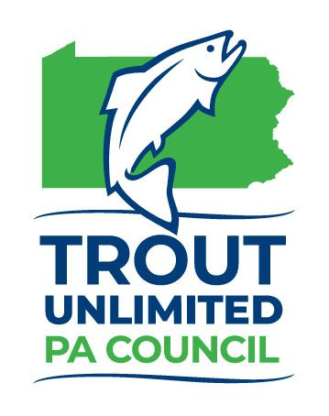
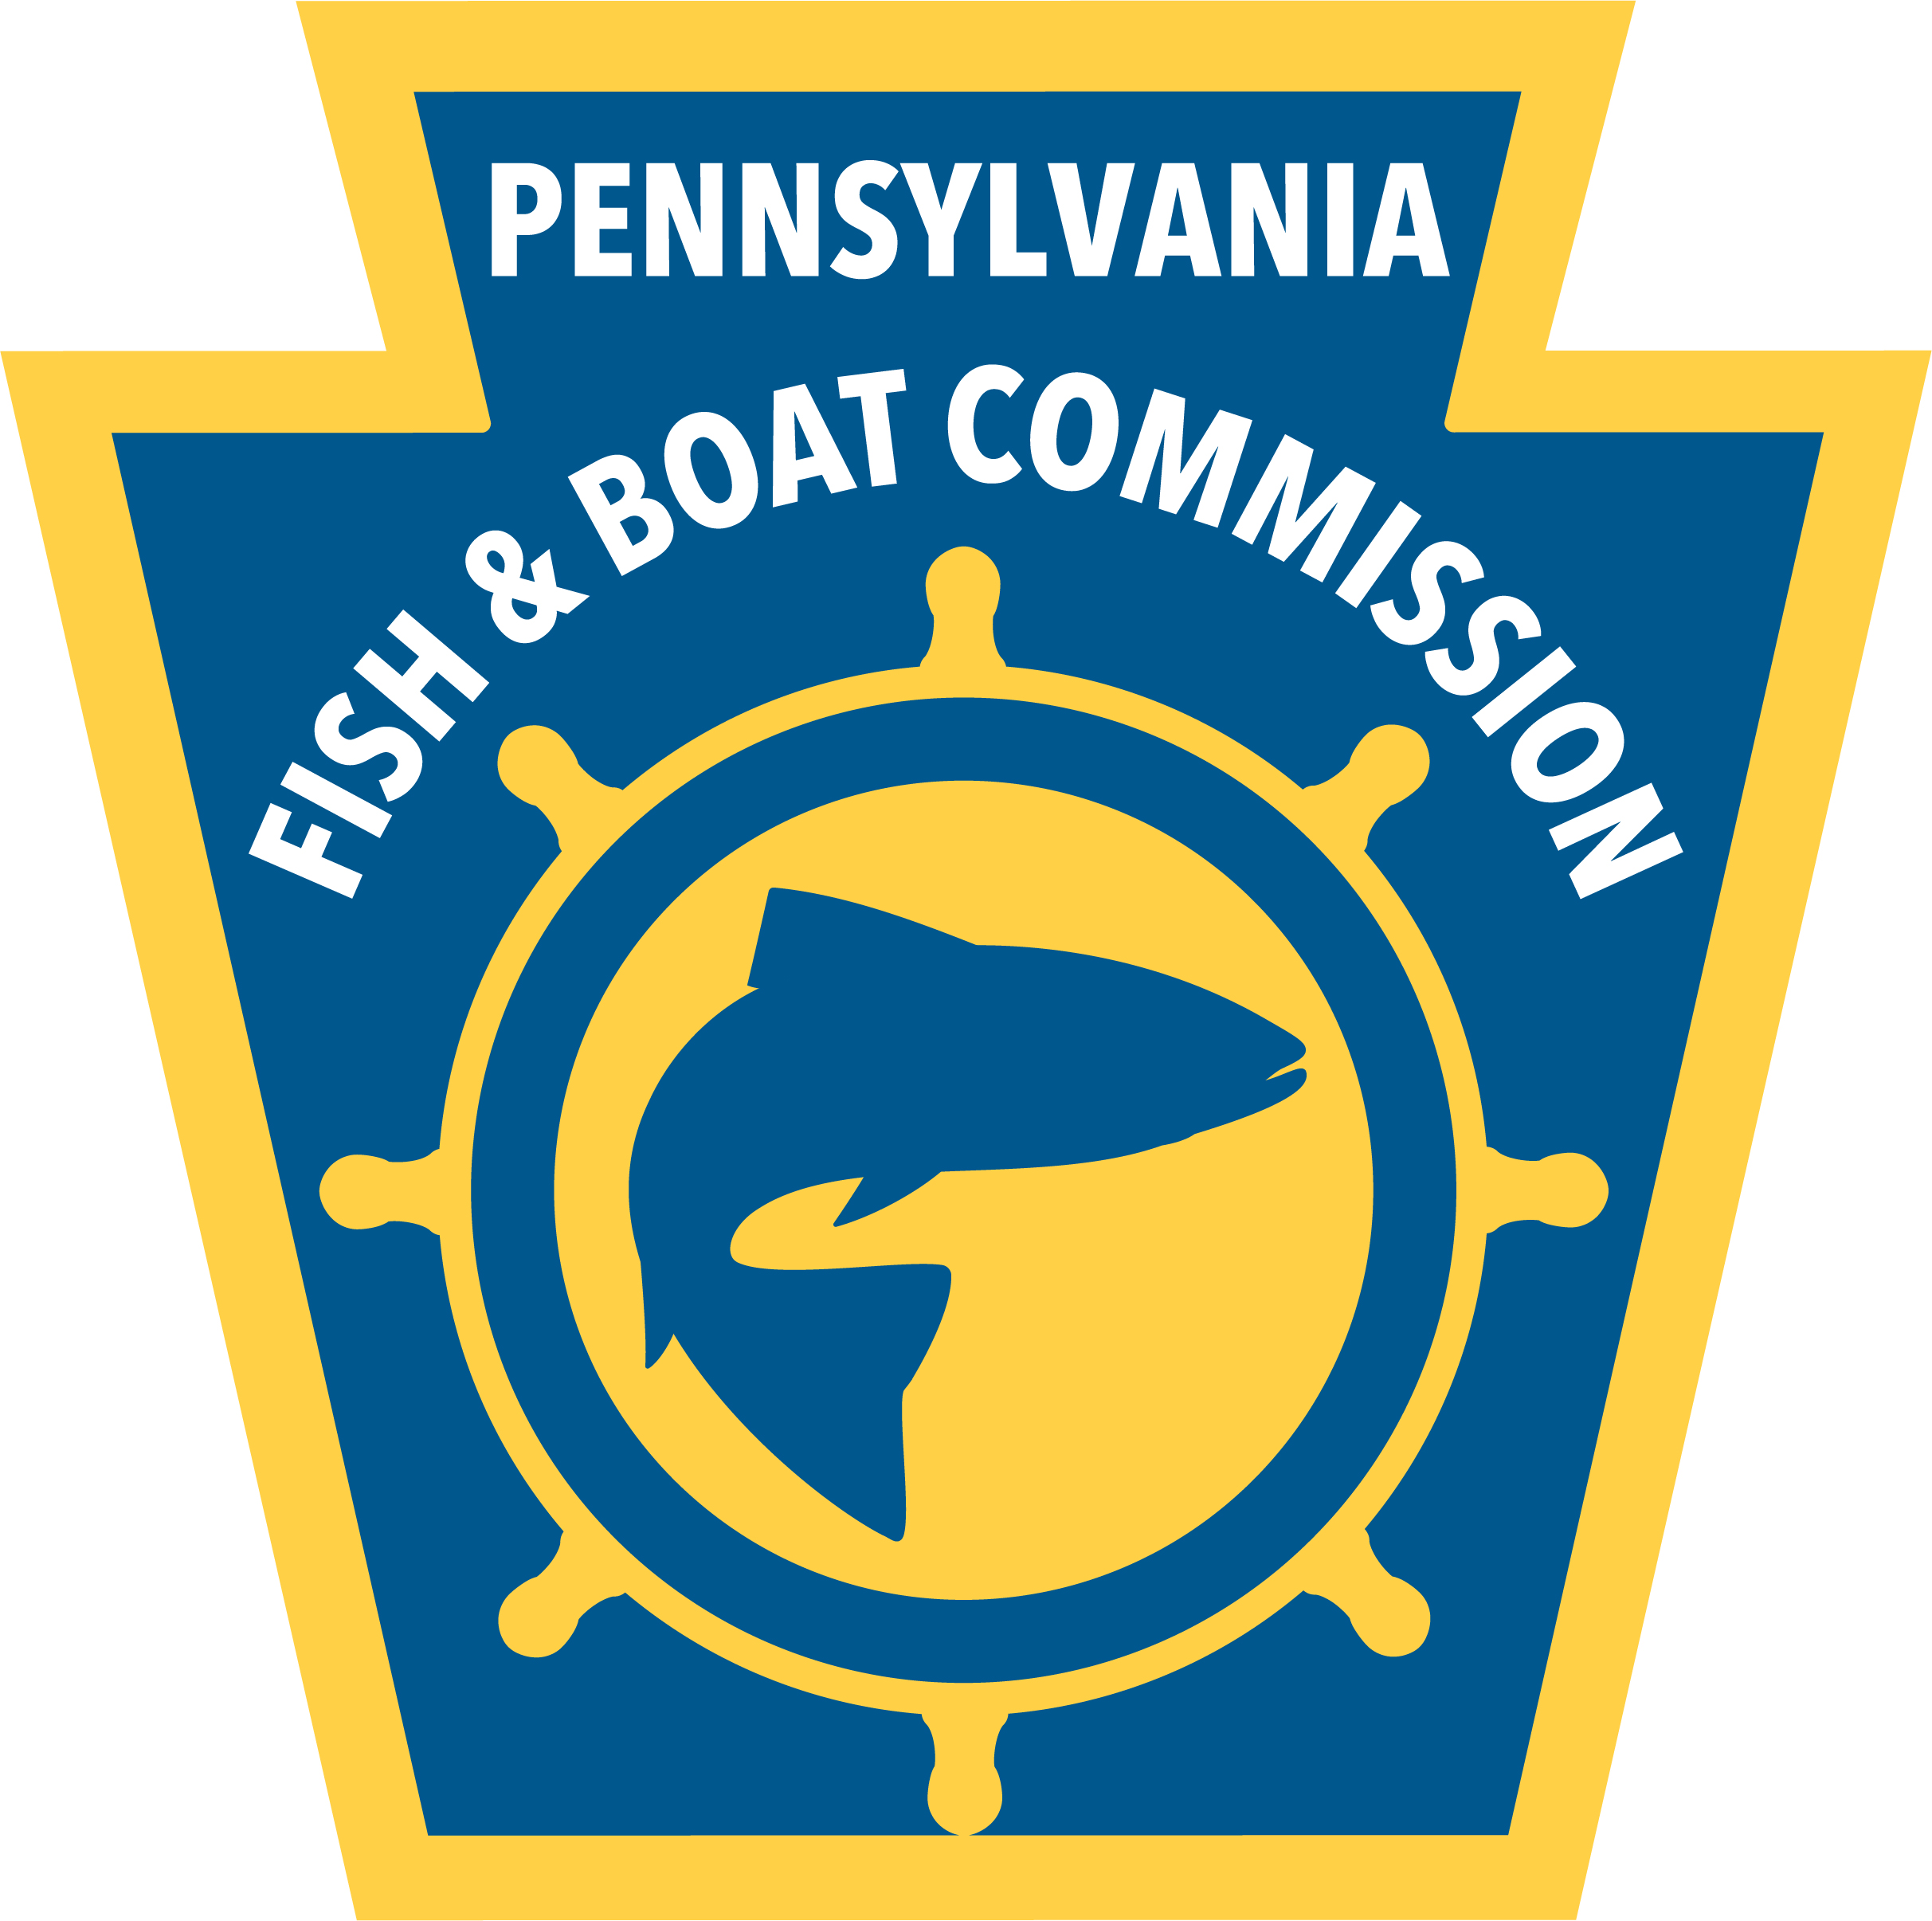

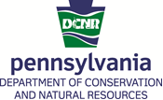
APPLICATION AND ATTACHMENTS CHECKLIST

Please assemble one copy of the grant application as follows:

Check  Box | Item  No. | Item | Description
 | 1 | Grant Application Cover Page | Provides organizational information.
 | 2 | Budget Narrative | Provides specific information regarding budget expenditures. Please include any additional pages or letters regarding fees from providers and documentation of costs for line items.
 | 3 | Project Narrative | Answer each question using the criteria provided for your project type.
 | 4 | Project Map | Map showing proposed project area. Please provide a clear and easy to photocopy map (example of maps can be found on the CHP website under “Grant Applications and Guidelines”.
 | 5 | Photos (Implementation projects only) | Include “before” photos of the project site taken from a location that can be repeated for “after” photos.
 | 6 | Permitting Information & Design Plans (Implementation projects only) | Include permitting information and design plans that have been developed for the project. If permitting is not in hand, describe what permits will be required and an estimate of how long it will take to acquire them.
 | 7 | Proof of eligibility for funding * | Documentation that your group or pass-through agent is a 501(c)3 non-profit organization AND is registered with the PA Bureau of Charitable Organizations. (Doesn’t apply to counties and municipalities.)
 | 8 | Letters of Support | Substantiates need for the project and shows collaboration with other organizations.
 | 9 | Landowner Commitment (Implementation projects only) | Please include a landowner agreement for implementation projects located on private property. Projects on public lands should provide a letter of authorization from the appropriate state agency.
 | 10 | Supporting Documents | Any additional documents or information that is important to understanding the proposed project. For implementation projects, please include the section(s) of the plan or document that lists your project as a recommendation.
* Note: If the applicant will be using another organization as a pass-through agent, a copy of the pass-through organization’s IRS Determination Letter must be provided.

CHP GRANT APPLICATION COVER PAGE
Project Title:
Project Type: Planning Implementation
Organization Name:
Name of the tax-exempt organization to which funds will be distributed (if different from the organization above):
Organization or Pass-through agent’s
Federal Employee ID Number or Tax ID Number:
Geographic area (please Attach Map):
Watershed: County:

Municipality(ies): Project Latitude / Longitude:

Stream Name: |  | Chapter 93 Stream Designation:  (CWF, HQ, EV, etc.)
Does the stream contain a naturally reproducing trout population?  Yes No  Class A? Yes No |  | Approximate % of stream  open for public use:
For implementation projects: Is this project included as a potential project in a Coldwater Conservation Plan (if yes, please list plan) If not, please provide the title of the document where project can be found.

Provide a one-sentence description of the project:

Total Project Cost: | Match Amount: |  | CHP Request:

CONTACT INFORMATION FOR ALL GRANT RELATED CORRESPONDENCE:
Please provide contact information for two individuals who will be associated with the project.
Main Contact Name and Title: | Secondary Contact Name and Title:
Address: | Address:
Phone: | Phone:
Email: | Email:
Project Narrative
Please provide the following information using the headings and criteria below based on your project type. The project proposal narrative should be no more than five pages in length. Project proposals will be evaluated on a 100-point review system with each component of the narrative eligible for the maximum number of points indicated below. Note: There are slightly different criteria for planning and implementation grants, so please make sure you are following the appropriate guidelines for your type of proposal.

COLDWATER CONSERVATION PLANNING CRITERIA

- Overview of Organization (10 points)
  - Provide background information about your organization including a statement of the organization’s mission.
  - State the goals and/or objectives of the organization.
  - Describe how your organization is uniquely suited for carrying out this project. Include recent successes, awards, and relevant initiatives.
  - Include a list of the organization’s officers and/or board members and their contact information.

- Project Justification (20 points)
  - Describe how the plan will benefit the watershed including the coldwater resources and the communities within the watershed. Consider environmental, economic, recreational, aesthetic, and other benefits.
  - Explain why this project is a priority for funding.
  - Provide any specific goals and objectives for the plan.

- Project Work Plan (25 points)
  - Describe the activities your organization will undertake and the approximate order of activities and events.
  - Define the types of data that will be collected. (Be specific: Fish surveys, macroinvertebrates, habitat assessments, water quality data, etc.)
  - Describe the protocols you plan to use for collection and analysis. If data will be sent to certified labs, please provide names and locations.
  - Describe the responsible party for each action and event if someone other than your organization’s staff and volunteers.

- Project Timeline* (15 points) (Plans should be completed within 18 months of receiving an award.)
  - Estimate when each activity is proposed to begin and end.
  - Estimate how long each activity is scheduled to last.
  - State the expected start and end date of the whole project.
  - Consider contingencies for adverse impacts or unforeseen circumstances that may affect project outcome or proposed timing of project implementation.
*Consider using a Gantt Chart or similar project timeline tool.

- Describe anticipated uses of the completed Plan (10 points)
  - Describe where/how stakeholders and others will be able to access the plan.
  - List how the organization plans to use or apply elements in the final plan.

- Project Partners (10 points)
  - List entities which will contribute to the success of the project and plan. Examples of partners include municipalities, county organizations, Trout Unlimited chapters, conservation districts, and watershed groups.
  - Describe how volunteers will be involved and what role they will play in project success in both the short and long term.
  - Include letters of support from partners and their commitment to the project.

- Project Budget (10 points)
  - Complete the attached Proposed Budget form. (Form does not count as part of five-page limit.)
  - Provide details about sources of additional project funding in the narrative portion of your application.

COLDWATER CONSERVATION IMPLEMENTATION CRITERIA

- Overview of Organization (10 points)
  - Provide background information about your organization including a statement of the organization’s mission.
  - State the goals and/or objectives of the organization.
  - Describe how your organization is uniquely suited for carrying out this project. Include recent successes, awards, and relevant initiatives.
  - Include a list of the organization’s officers and/or board members and their contact information.

- Project Description (30 points)
  - Describe the project and explain how it aligns with both the CHP goal of enhancing, conserving, or protecting coldwater streams and with your organization’s mission. Photos can be included.
  - Define the specific goals and objectives of the project.
  - Explain why this project is a priority for funding.
  - Is the project new or a continuation of another project? Describe any design work and permitting that has been completed. If permitting is not in-hand, please describe what permits will be needed and a timeline for obtaining them.
  - How will this project be sustained in future years? Provide details on any maintenance, monitoring, or additional costs that are anticipated after the proposed project is complete. (Note: CHP Project funding awarded through this RFP must be used within 18 months of being awarded and cannot, therefore, be used for long-term monitoring, operation, or maintenance. Projects that are likely to have long-term success without extensive monitoring will be given priority. If the proposed project will need expensive long-term monitoring and maintenance, you must provide information regarding available funding for those activities.)

- Projected Outcomes (15 points)
  - Please include appropriate metrics for measuring project success. For example, linear feet of streambank restored or protected, number of habitat structures installed, feet of streambank fencing installed, number of volunteer hours, number of people reached through outreach or training, miles of stream reconnected/opened due to fish passage improvement, etc. Contact CHP for additional suggestions if these do not fit your proposed project.
  - Describe how you will measure project outcomes.

- Project Timeline* (15 points) (Projects should be completed within 18 months of receiving an award.)
  - Estimate when each activity is proposed to begin and end.
  - Estimate how long each activity is scheduled to last.
  - State the expected start and end date of the whole project.
  - Consider contingencies for adverse impacts or unforeseen circumstances that may affect project outcome or proposed timing of project implementation.
*Consider using a Gantt Chart or similar project timeline tool.

- Project Partners (20 points)
  - List entities which will contribute to the implementation and success of the project such as municipalities, townships, TU chapters, conservation organizations, watershed groups and conservation districts.
  - Describe how volunteers will be involved and what role they will play in project success in both the short and long term.
  - Provide letters of support and/or landowner agreements.

- Project Budget (10 points)
  - Complete the attached Proposed Budget form. (Form does not count as part of five-page limit.)
  - Provide details about sources of additional project funding in the narrative portion of your application.

Attachments

(Both project types)

Please attach the following to your narrative:

- Map showing proposed project area. Please provide a clear map. Example of acceptable maps can be found on the CHP website under “Grant Applications and Guidelines.”
- Proof of eligibility for funding (e.g., Copy of Certificate of Incorporation and/or IRS 501(c)3 determination letter).*
- Letters of support for the project.
- If project is on private property, please include letter from landowner showing commitment for the project. If project is on public land, please provide a letter of authorization from the managing agency. (Implementation projects only.)
- Any other information describing your organization or proposed project that you believe is important.
- If the proposed project was recommended in a document other than a CHP Coldwater Conservation plan, please provide a copy or link to the document. (Implementation grants only.)
*Note: If your group does not have 501(c)3 status, you must use a pass-through agent and provide proof of their eligibility for funding.
Proposed Budget

LINE ITEM | DESCRIPTION/ DETAILS/ EXPLANATION | CHP GRANT FUNDS Requested | LOCAL CONTRIBUTION |  | Total Project Costs
LINE ITEM | DESCRIPTION/ DETAILS/ EXPLANATION | CHP GRANT FUNDS Requested | Cash | In-kind | Total Project Costs
PROFESSIONAL SERVICES/ LABOR
TRAVEL (miles x $0.58)
EQUIPMENT & SUPPLIES (Please list each item. Attach a separate sheet if necessary.)
CONTRACTUAL/ CONSTRUCTION (Please be specific)
ADMINISTRATIVE (Postage, mailings, phone, printing, etc.)
MEETING SPACE/ RENTAL
OTHER (Itemize)
Total

PLEASE SUBMIT ONE COPY via email BY march 4, 2022 TO:
Rachel Kester
c-rkester@pa.gov

Appendix A

Coldwater Conservation Planning Guidelines

Coldwater Heritage Partnership planning grants provide funding to conservation organizations to create coldwater conservation plans that can be used by municipalities, local businesses, state and local governments, conservation organizations and communities for the conservation and protection of Pennsylvania’s coldwater resources.

Coldwater Conservation Plan Format
All plans should be submitted in one digital document (including all text, tables, figures, and maps). There is no “one size fits all” Coldwater Conservation Plan format since each watershed is unique, and the goals, needs and capacities of each organization creating the plan are different. However, the basic elements of a plan, described below, should be included in the final Coldwater Conservation Plan.

- Introduction and Background
Provide an overview of the organization and general background information about the project area.

- Watershed/Project Area Description
  - Location- geographic location within the state including counties, townships, etc. Include latitude and longitude whenever possible.
  - Size of watershed, drainage area, stream length or order
  - List of streams containing naturally reproducing trout and Chapter 93 stream designation
  - Land use (farming, residential, commercial/ industrial, etc.)
  - Ownership (%)- public and private (area assessed)
  - Stream impairment data- 303(d) list status (cause and source of impairment)

- Detailed Map(s) of Watershed with Streams Segments, etc.
Maps can show many of the above listed elements and should also include sampling and monitoring locations.

- Previously Existing Information and Current Data Analysis
  - Characterize and discuss relevant existing information, data, and studies (hydrology, geology, biological, historical, etc.)
  - Current Biological Monitoring and Assessments: Data and discussion related to:
    - Habitat assessments: In-stream and riparian corridor
    - Aquatic organism passage (stream crossings)
    - Aquatic life (invertebrates and fish)
    - Aquatic and terrestrial invasive species that impact stream or riparian corridor
  - Water quality
    - pH, alkalinity, temperature, DO, metals, nutrients, bacteria, etc.
  - Methodology used during data collection

- Areas of Concern and Opportunity
This section shall address problem areas or unique features within the watershed or specific stream section. Include photos where possible (please use discretion when working with private landowners).

- Recommendations
Following collection and data analysis, develop recommendations to serve as actions for the restoration, maintenance, or enhancement of the watershed. Include goals, clearly defined objectives and specific projects which can be undertaken in the future. These recommendations and next steps should be as specific and tangible as possible. A large-scale restoration project, for example, should be broken down into logical, attainable smaller steps. Keep in mind that future funding opportunities may depend on the ability of the funder to form direct links between their priorities and requirements and the specific projects recommended in your completed plan. General statements of need or loosely defined recommendations will make future implementation efforts more difficult. Recommendations for efforts that promote, support, and implement coldwater resource conservation awareness initiatives, education and outreach programs, and stewardship opportunities are also strongly encouraged.
Additionally, consider the opportunity for a Chapter 93 designation upgrade and what specific steps would be necessary.

- Future Funding Opportunities and/or Potential Partners
Consider including known or possible funding opportunities (grants, foundations, donations) and partners who may be available to help implement and carry out the recommendations. What are the organization’s proposed next steps upon approval of the coldwater conservation plan?

- Summary and Conclusions
A final summary of the process, data, lessons learned, partner recognition, recommendations, and next steps.

- References

- Appendices
Include maps, figures, tables, and photographs not included in the narrative.

In addition to the final conservation plan, grantees will be required to submit a final expense form (found on the CHP website).

Coldwater Conservation Implementation Reporting Guidelines

All grantees are required to complete a final report and final expense form (found on the CHP website) upon completion of the project. CHP implementation projects are unique as are their outcomes, outputs, and measures of success. However, the following information will be expected as part of the final project report:

- Information about the public meeting held after receiving the grant and prior to beginning the project
  - Date and location of meeting(s)
  - Organizations represented by attendees (In order to protect privacy, you do not need to share names or emails.)

- Before and after photos of the project site(s) taken from the same vantage point.

- Project summary
- What did you do and when?
- How did you do it?
- Who was involved?
- Where did it take place?

- Project outcomes
  - Were all project objectives met?
  - If not, which ones and why not?
  - Is project considered complete? If not, what remains to be accomplished?

- Project sustainability/next steps
  - Discuss the long-term sustainability of the project. What are potential threats to sustainability?
  - Describe monitoring, operation, and maintenance plans for the project.
  - Describe any future efforts that would increase the benefits of the current project.

- List partners and volunteers and describe their involvement in the project including number of people, number of donated or in-kind hours, etc.

- Accomplishments and outputs
  - Observed or measured improvement to overall condition of the stream or watershed.
  - Natural stream channel projects:
    - Number of linear feet/acres improved (Remember to account for both stream banks if applicable.)
    - Number of trees planted, if applicable
    - Number of habitat structures placed, if applicable
    - Number of best management practices (BMPs) installed
  - Barrier removal
    - Number of stream miles reconnected or opened up
  - Preservation projects:
    - Number of linear feet of stream and/or acres preserved

www.coldwaterheritage.org

